The line of the actual forecast states that the 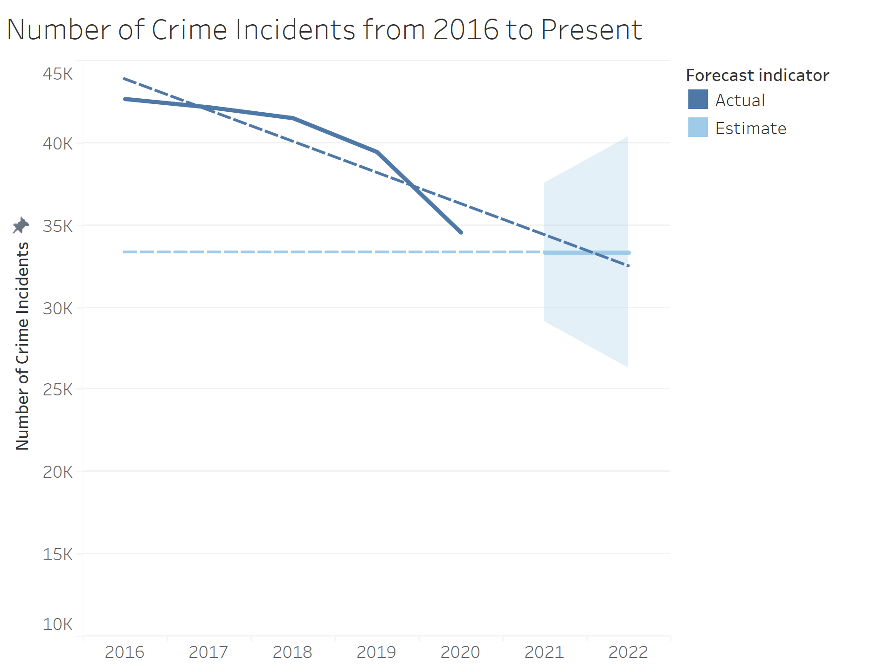

Number of Crime Incidents = -1894.6\*Year of Incident + 3.86\*10⁶.

According to the graph, there should be around 30,000 to 35,000 incidents for the years 2021 and 2022. If we apply the equation, there will be about 31,014 crime incidents for 2021 and 29,119 for 2022. Therefore, crime incidents are likely to continue decreasing. However, due to COVID-19 and its many effects, it is possible that the data for the year of 2021 will be considered an outlier, so there is a chance that the data is nowhere between the shaded trapezoidal region in the graph above.